Update for key stakeholders
13 October 2022

Vaccination
In the NHS Highland area as a whole, from 3 October to 9 October we delivered –
12,057 COVID-19 vaccinations (13,986 the previous week)
16,150 Flu vaccinations (17,697 the previous week)
28,207 total vaccinations given (31,680 the previous week)
Since the programme started on 5 September we have delivered -

46,837 COVID-19 vaccinations
56,969 Flu vaccinations
103,806 total vaccinations given

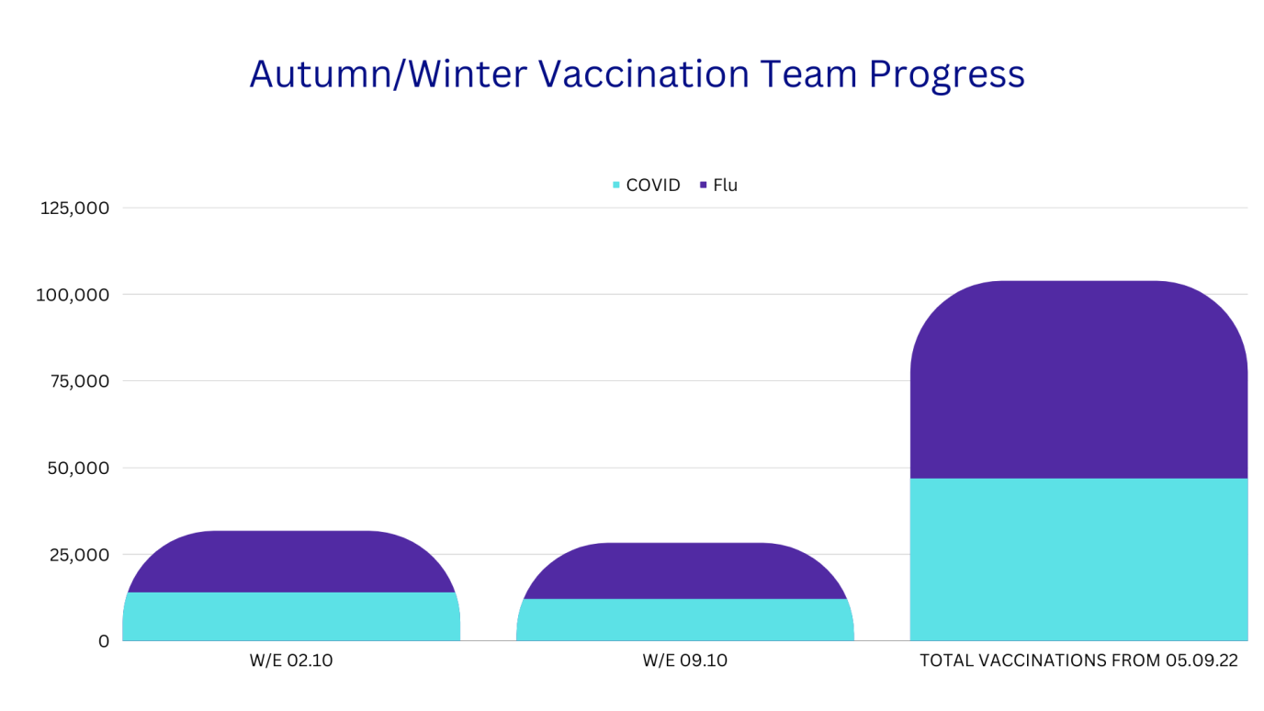

Care at Home Services – Highland

NHS Highland is responsible for adult social care in the Highland Council area and works with independent and third sector providers to deliver care at home. Across Scotland, care at home services are increasingly pressured and fragile.
In the Highland Council area, NHS Highland has:
- Agreed and issued a Joint Scottish Care, The Highland Council and NHS Highland letter of support to people who use commissioned services, to explain the context and let them know of potential changes to visit timing (unless these timings are critical) and durations, to build in flexibility for service providers. An information leaflet is also being prepared to share with people using services and their families.
- Agreed and implemented a block contract from 1 November 2021, to provide delivery and income certainty, enabling providers to employ staff on a wider variety of contract terms to assist recruitment and retention.
- Implemented the Scottish Government pay increase to £10.50 per hour four months early, with a commitment that NHSH is actively exploring opportunities to provide further stabilising support if necessary and possible.
- Ongoing regular sector dialogue to address and release capacity.

Care at home services - Argyll and Bute

Like other HSCPs across Scotland we are facing significant recruitment and retention challenges in providing sustainable care at home services. There are a number of reasons for these challenges including competition for staff from employers in other sectors and budget pressures due to rising fuel costs and the cost of living.

We have been actively looking into how additional support can be given to care at home services and we have identified and approved a number of proposals. These include an hourly rate increase in the pay for staff, changes to the way of working in our localities to develop a more inclusive partnership approach and we are also looking at the frequency of how we pay providers for the work they do to help them.

We have been in communication with all providers in relation to these proposals and we are arranging meetings with them next week to discuss them in more detail. We are hopeful that this will help address some of the challenges they are experiencing and help them sustain and develop their business going forward. We would also like to thank all our providers and carers for the work they are doing every day for the people who use our care at home services.

Feedback
If you have comments or queries please contact nhshighland.feedback@nhs.scot

